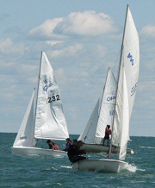20**23** Ontario Sailing Regional  
Championships Western Ontario

South Port Sailing Club — Tecumseh ON  
Saturday – Sunday, 2023 August 12 – 13

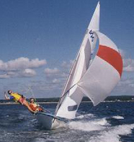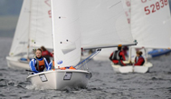*Welcome to the eighth annual Western Ontario regatta hosted by SPSC for Lasers, Radials, Bytes, Optimists, Force 5’s and Club 420s*

SPSC is a great sailing venue on Lake St. Clair. Competitors and their families are welcome to camp and make use of the club showers, kitchen, BBQs and fire pit.

# Accommodations

Free camping on the club grounds and limited billeting available.

Campers are asked to pre-register for camping.

Campers under 18 must have an adult supervisor on site

# Registration

Please read the Notice of Race below and fill-in the online registration form.

# Info Contact

### Chair of Organizing Committee

Mo Regnier mo@greatadventuretours.com

519 992 0010 (cell)

# Other Contacts

### Chair of Race Committee

Jin Frati spsc.rear.commodore@gmail.com

### Race Officer

Matt Draisey rc@southportsailingclub.com

# Schedule of Events

| **Friday** | |
| --- | --- |
| **1800 – 2100** | **Registration & Welcoming** |
| **Saturday** | |
| **0900** | **Breakfast** |
| **1000 – 1100** | **Registration** |
| **1130** | **Skippers' meeting** |
| **1200** | **Harbour start** |
| **1300** | **First warning signal …** |
| **1600** | … **no warning signal after** |
| **1800** | **Dinner at SPSC** |
| **Sunday** | |
| **0700** | **Breakfast** |
| **0915** | **Harbour start** |
| **1000** | **First warning signal …** |
| **1400** | … **no warning signal after** |
| **1530 – 1600** | **Awards** |